BIOMEDICAL EQUIPMENT INSPECTION REPORT

Hospital Name: ABC Hospital
Department: Biomedical Engineering
Prepared By: Ubbad Raza

Date: 26th February, 2026

Table of contents
Contents
Introduction 2
Equipment Details 2
Inspection Procedure 3
Observations 3
Conclusion 3
Bibliography 3

Introduction
Equipment inspection in hospitals is essential to ensure patient safety and prevent accidents caused by faulty devices. [1] Regular checks help detect wear and tear in critical machines such as ventilators, monitors, and imaging systems before they fail. Proper inspection also ensures compliance with healthcare regulations and quality standards set by organizations like World Health Organization. [2] It reduces downtime of medical equipment, allowing healthcare professionals to provide uninterrupted care. Routine maintenance and inspection also extend the lifespan of expensive hospital equipment. [3] Overall, equipment inspection supports accurate diagnosis, effective treatment, and a safe healthcare environment.

Equipment Details
Equipment Name | Equipment ID | Department | Last Calibration | Status
ECG Machine | EQ-001 | Cardiology | 15-Nov-2025 | Valid
Ventilator | EQ-002 | ICU | 10-Oct-2025 | Due
Defibrillator | EQ-003 | Emergency | 9-Jan-2025 | Overdue
Patient Monitor | EQ-004 | ICU | 20-Dec-2025 | Valid
Infusion Pump | EQ-005 | ICU | 8-Dec-2025 | Valid
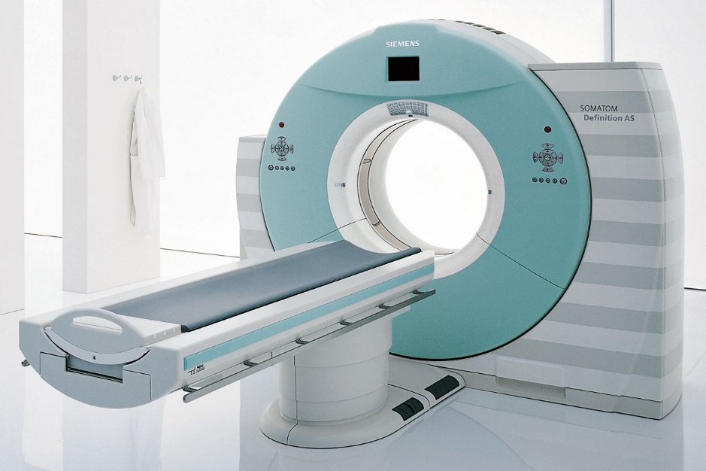
Figure 1: CT (Computed Tomography) scanner

Inspection Procedure

Observations

Conclusion

Bibliography

[1] | J. G. Webster, Medical Instrumentation: Application and Design, Hoboken: John Wiley & Sons, 2009.
[2] | R. K. Rangayyan, Biomedical Signal Analysis: A Case-Study Approach, Hoboken: IEEE Press, 2002.
[3] | S. B. Park and N. V. Thakor, "Detecting motor intent in forearm electromyography signals," IEEE Transactions on Neural Systems and Rehabilitation Engineering, vol. 11, no. 3, p. 210–219, 2003.

